WASHINGTON PARISH COUNCIL MEETING

MINUTES of the monthly meeting of Washington Parish Council held on Monday 4th August 2025 in the Washington Village Hall (Doré Room) School Lane, Washington RH20 4AP

PRESENT: Cllr C. Brookes, , Cllr A Dillaway, Cllr B Hanvey, Cllr O. Jupp, Cllr T Keech, Cllr M. Shaw, Cllr J. Thomas and Cllr A Lisher (Chairman).

IN ATTENDANCE: Cllr J Grech (HDC). Apologies were received from Cllr P Marshall (WSCC), Cllr E. Beard (HDC and Cllr C Fisher (HDC).

ALSO: Ms Z. Savill (Clerk to the Council). There were no members of the public.

ABSENT: None

Cllr Lisher (Chairman) opened the meeting at 7:00pm

FC/25/8/1 Apologies for Absence
All present. There were no apologies from members.

FC/25/8/18 Declaration of Members’ Interests and requests for Dispensations.
None declared as defined under the Localism Act 2011 and the Council’s Code of Conduct.

Cllr Dillaway requested a dispensation for his previously declared interest relating to item
FC/25/8/18 to remain for the discussion in order to respond to any questions from members.

The Council RESOLVED to grant the dispensation in accordance with the Standing Orders
item 13 I (i) and (iii). Cllr Dillaway abstained from voting on this item.

FC/25/8/3 Minutes of the last Full Council meeting
The Council RESOLVED to APPROVE the minutes of the Full Council Meeting held on
on 7th July 2025 as an accurate record and were duly signed by the Chairman..

FC/25/7/4. Public Forum
There were no members of the public in attendance or written representations.

The Chairman proposed and it was RESOLVED to bring forward Agenda item 8 ‘Urgent Matters’
so that Cllr Grech could respond before she leaves the meeting.

FC/25/7/5 Urgent Matters

Flooding in School Lane
Cllr Thomas reported on severe flooding in School Lane following heavy rainfall on 1st
August, and that this was increasing in frequency because of blocked road drains.

It was noted that the drains on higher ground at The Holt had collapsed and were blocked like
those in nearby Chanctonbury Close and likely contributing significantly to the problem.
Members queried if HDC would know the legal responsibility of both roads, given the
presence of former local authority properties. Cllr Grech agreed to make enquiries.

Following a discussion the Council RESOLVED to write to the Highways Authority requesting
that all the road drains are cleared, including those in School Lane and its junction with London
Road.

FC/25/7/6. Reports from County and District Councillors

WSCC Reports
There were no reports.

HDC Reports

EV ChargePoint for Community Landowners Webinar 30th July 2025
Cllr Grech reported that she would forward information to the Council on how it can get
involved and access funding for EV charge points on community land and car parks

Village Pub
Cllr Grech reported that she would follow up the Council’s recent email to the SDNPA requesting
compliance on outstanding planning matters regarding the wall and landscaping scheme at the
pub.

Devolution and Local Government Reorganisation: HDC Community Asset Transfer
Cllr Grech reminded the Council that HDC is seeking to transfer its assets in the parish. The
Chairman commented that the Council had recently considered this and agreed that taking on
more assets would place an unwanted financial burden on the Council.

Cllr Lisher thanked Cllr Grech for her reports before she left the meeting.

FC/25/8/7. Co-option
The Chairman reported that no applications had been received for the Councillor vacancies.

FC/25/8/8 Planning applications, Decisions, Appeals and Compliance Matters
It was noted that there were no notifications received of applications ,appeals or compliance
matters in the parish. The Chairman reported that the application for cabins at North Farm,
Wiston had recently been approved by the SDNPA.

FC/25/8/9 Clerk’s Report
The Council noted the report of actions and matters arising on Council business since the last
meeting (Appendix A).

Devolution and Local Government Reorganisation
The Council noted that presentation slides and a recording of the Devolution and LGR
Stakeholder briefing held on 30th July 2025 would be distributed by the Clerk once
these became available

FC/25/8/10 Committees and reports from Outside Bodies

Draft Minutes of the meetings of the Planning & Transport Committee and OSRA Committee
The Council RESOLVED to note the draft minutes of the meetings of the Planning & Transport
Committee and OSRA Committee held on 21st July 2025. The draft minutes of the Finance
Committee meeting of the same date were deferred to the next meeting. There were no
recommendations for consideration from the committees.

, Minutes of the HALC meeting
The Council RESOLVED to note the minutes of the HALC meeting on 19th June last with
supporting papers on Local Government Reorganisation, HDC Asset Transfer, and the
Government’s planning committees consultation, all circulated before the last meeting

Devolution and Local Government Reorganisation stakeholder briefing on 30th July 2025
Cllr Dillaway reported on his attendance of the WSCC online briefing of the LGD process in
West Sussex. He explained that parish council attendees had expressed concerns about taking on
assets from higher tier Authorities without funding being made available, and those experienced
in the LGD process had similarly urged caution.

FC/25/8/11 Neighbourhood Plan
The Chairman advised that there were no further updates on the SSWNP since those
reported at the last meeting.

FC/25/8/12 Delegated decisions
The Clerk advised that there were no delegated decisions since the last meeting.

FC/25/8/13 Financial
Payments
The Council RESOLVED to APPROVE the following payments of invoices totalling £5,596.80.

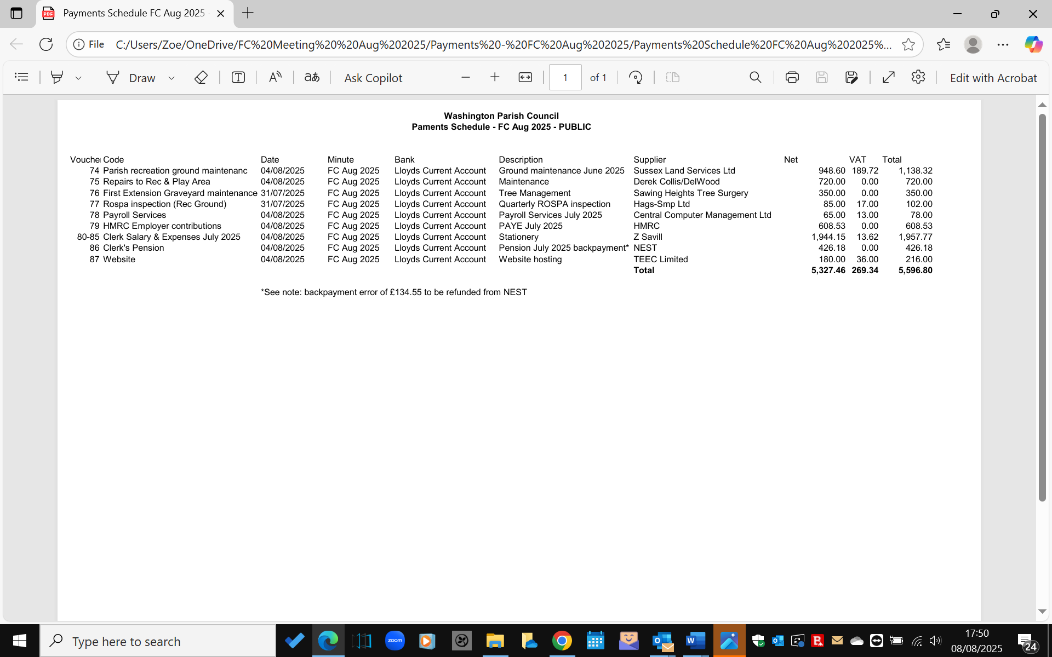

Bank Reconciliations
The Council RESOLVDED to NOTE the bank reconciliations for the month of July on the
Council’s following accounts:

Lloyds Community Account: £15,196
Nationwide Business Savings Account: £56,512.09
Redwood Business Savings Account: £50,000

Quotation for laptop repair
This item was deferred.

Quotation for 3-year extended warranty of the Council’s 2 Speed Indicator Devices
The Council considered and RESOLVED not to extend the warranty of the SIDs for
£199 x 2 from the supplier. It was agreed that the large number of exclusions of the warranties
made it an unattractive option, and that the Council already had a management arrangement with
Wilbar Associates Ltd to look after the devices..

Quotation for Council bespoke training
The Council RESOLVED to engage Mulberry Local Authority Services Ltd for a two-hour
training session on Monday 29th September 2025, for the cost of £300 plus mileage
Cllr Dillaway agreed to draft a list of topics to cover, with the Clerk’s input.

FC/25/8/14 Internal Financial Controls
Cllr Keech reported on his review of the Council’s Financial Internal Financial Controls for
the first quarter of 2025.26 and that he did not find any issues. The report was duly signed by
Cllr Keech.

FC/25/8/15 Correspondence
The Council RESOLVED to note correspondence previously distributed for information.

FC/25/8/16 Chairman’s announcements
The Chairman advised on an important survey on the future of local government at:
https://www.shapingwestsussex.org/p/c/shaping-west-sussex/shaping-west-sussex
and that members who would like to respond as residents, should do so before the
closing date on 13th August. Details of the survey were also published on the Council’s website.

FC/25/8/17 Dates and Times of the next meetings
Full Council Meeting: Monday 1st September 2025, 7:30pm
Planning & Transport Committee: Monday 15th September 2055 7:00pm
OSRA Committee: Monday 15th September 2025 7:45pm

FC/25/8/18 Written Motion
The Council considered a written motion for the Council to purchase and manage a defibrillator
with equipment and grit bin at John Ireland Way, Milford Grange, in the parish.

Cllr Hanvey declared a personal interest as a resident and did not take part in the discussion or
voting.
The written motion by Cllr Keech was previously distributed via Drop Box at:
https://www.dropbox.com/home/FC%20Meeting%204th%20August%202025# with
advice from HDC and WSALC confirming that this would meet the criteria for CIL funding
The latest statements of available parish CIL monies were distributed.

Cllr Dillaway confirmed as a director of the Management Company for Milford Grange that
the Council would be assured of unfettered access to the defibrillator equipment and grit
as the legal owners. It was noted that the Council already owns and manages the noticeboard
on the estate.

Following a discussion the Council RESOLVED to purchase the defibrillator, cabinet, and
grit bin up to a cost of £3,000 from CIL funds as such provision would be in the interest of the
community as a whole. The Clerk to work with the Milford Grange Management Company to
arrange for supply and installation of the equipment. CIL funding to be transferred from the
Council’s savings account if required for the purchases. The assets to be added to the Council
Fixed Asset register, to be managed by the Council and included in future insurance summaries

Further, the Council RESOLVED to seek clarification from HDC on when the £15,780.14 parish
CIL monies can be expected from the neighbouring care home development at the former
Clayton Kennels site.

FC/25/8/18 Confidential Session
The Council RESOLVED that under the Public Bodies (Admissions to Meetings) Act 1960, the
public and representatives of the press and broadcast media be excluded from the meeting
during consideration of the following items of business as publication would be prejudicial to
the public interest because of the confidential nature of the business to be transacted.

FC/25/8/19 Washington Recreation Ground Charity: Rampion 2 legal matters
To Consider acceptance of terms of business of Moore Barlow LLP for handling legal
matters regarding access to the Rampion 2 cable route on the Washington Recreation Ground..

This item was deferred to the next meeting, pending business terms and engagement
letter from the solicitor, and written assurance from Rampion on the fees arrangements.

There being no further business to transact, the meeting was closed at 8:46pm.

Signed………………………………….

Dated…………………………………..

Glossary of acronyms

AIRS Action in Rural Sussex
AGAR Annual Governance and Accountability Return
CIL Community Infrastructure Levy
CPRE Council for the Protection of Rural England
CSW Community Speed Watch
DCO Development Consent Order
DPO Data Protection Officer
HALC Horsham Association of Local Councils
HDC Horsham District Council
HDPF Horsham District Planning Framework
HAMSVA Horsham and Mid Sussex Voluntary Association
ICO Information Commission Office
LGD: Local Government Devolution
LGR: Local Government Reorganisation
LGS Local Green Space
NALC National Association of Local Councils
SSWNP: Storrington & Sullington and Washington Neighbourhood Plan
NPPF National Planning Policy Framework
PCC Police Crime Commissioner
PINS Planning Inspectorate
PROW Public Rights of Way
SDNPA South Downs National Park Authority
SDNP South Downs National Park
SHELAA Strategic Housing Economic Land Availability Assessment
SID Speed Indicator Device
SLCC Society of Local Council Clerks
TPO Tree Preservation Order
TRO Traffic Regulation Order
TTRO Temporary Traffic Regulation Order
VAS Vehicle Activation Device
WPC Washington Parish Council
WRGC Washington Recreation Ground Charity
WSALC West Sussex Association of Local Councils
WSCC West Sussex County Council

